**Advance Excel Assignment 4**

Q1. To use the ribbon commands, what menu and grouping of commands will you find the Insert and Delete command?

Solution: To add ribbon command follow the below step:

1. Open Office app or File on the top left corner of excel.
2. Click on Options from the bottom-left corner. Quick note: If you have a blank document open, click the File menu to access the Options button. Alternatively, you can also right-click anywhere in the Ribbon and select the Customize the Ribbon option to access the settings.
3. Click on Customize Ribbon.
4. Use the "Customize the Ribbon" drop-down menu and select the Main Tabs option (if applicable).
5. Select the tab and then the custom group you want to add new commands.
6. (Optional) Click the New Tab button to add a new section to include all your custom commands. Quick note: You will also need to right-click the tab and select the Rename option to set a custom name for the tab.
7. Click the Rename button.
8. Confirm a name for the tab.
9. Click the OK button.

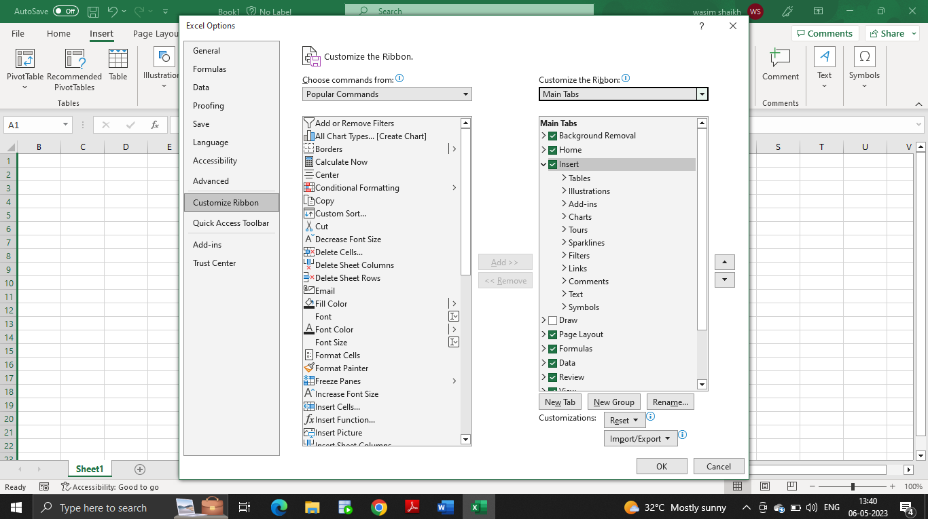

To remove ribbon command follow the below step:

1. Open Office app or File on the top left corner of excel.
2. Click on Options from the bottom-left corner.
3. Click on Customize Ribbon.
4. Use the "Customize the Ribbon" drop-down menu and select the Main Tabs option (if applicable).
5. Select the tab and then group you want to remove new commands from. Quick note: While you cannot edit items on existing tabs, you can remove items from most places, including from existing and custom tabs.
6. Right-click the command and select the Remove option.
7. (Optional) Right-click the empty group and select the Remove option.
8. Click the OK button.



Q2. If you set a row height or column width to 0 (zero), what happens to the row and column?

Solution: The row height is set to zero then the row will be hidden and if the column width is set to zero then the height will be hidden.

3. Is there a need to change the height and width in a cell? Why?

Solution: In excel if we enter any value in a particular cell and the text is hidden then we can adjust the height and width of the cell which will allow us to read the text in a particular cell.

4. What is the keyboard shortcut to unhide rows?

Solution: Ctrl + Shift + 9 is the keyboard shortcut to unhide rows

5. How to hide rows containing blank cells?

Solution: In the Home ribbon tab click on Find & Select and click on Go To Special

Select Blanks and then click on “OK” button

The cell with blank value will get highlighted then press ctrl + 9 to hide those rows.

6. What are the steps to hide the duplicate values using conditional formatting in excel?

Solution: In the excel files select the range and go to conditional formatting and Click on Highlight Cell Rules and Click on Duplicate values and this will highlight the rows with duplicate value.

You can then select those rows with duplicate values and hide them using Ctrl + Shift + 9